Preliminary

To begin with the task, we reduced the level of detail from 28 x 28-pixel image to 14 x 14 using down_sample_image function, and then we split the dataset into training and testing set in 5000:37000.

Analysing data using

**Regularized multinomial logit model (using the LASSO penalty)**

To get the best lambda value for the multinomial logistic regression we used cv.glmnet function, the mentioned function performs 10 fold cross validations to output us the best lambda value. We used the following

cv.glmnet(as.matrix(x.train[,-1]),x.train[,1],family="multinomial",type.measure ="class").

We plot the lambda against the misclassification error:

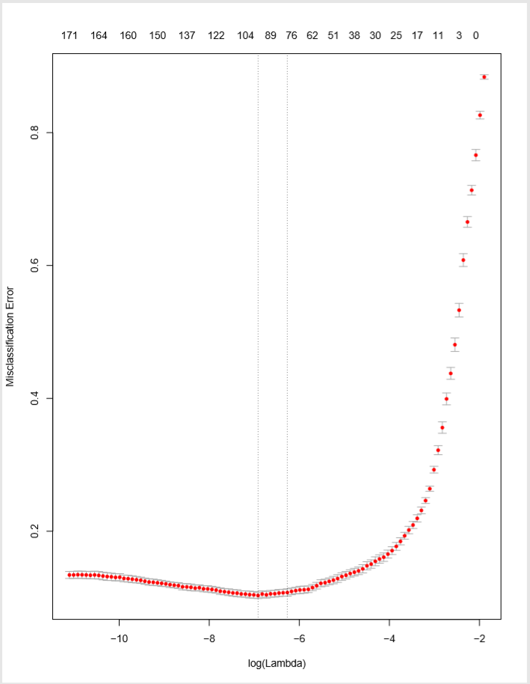

We get the following results

|  |  |
| --- | --- |
| MINIMUM LAMBDA VALUE | 0.0009904169 |
| ACCURACY | 89.03% |